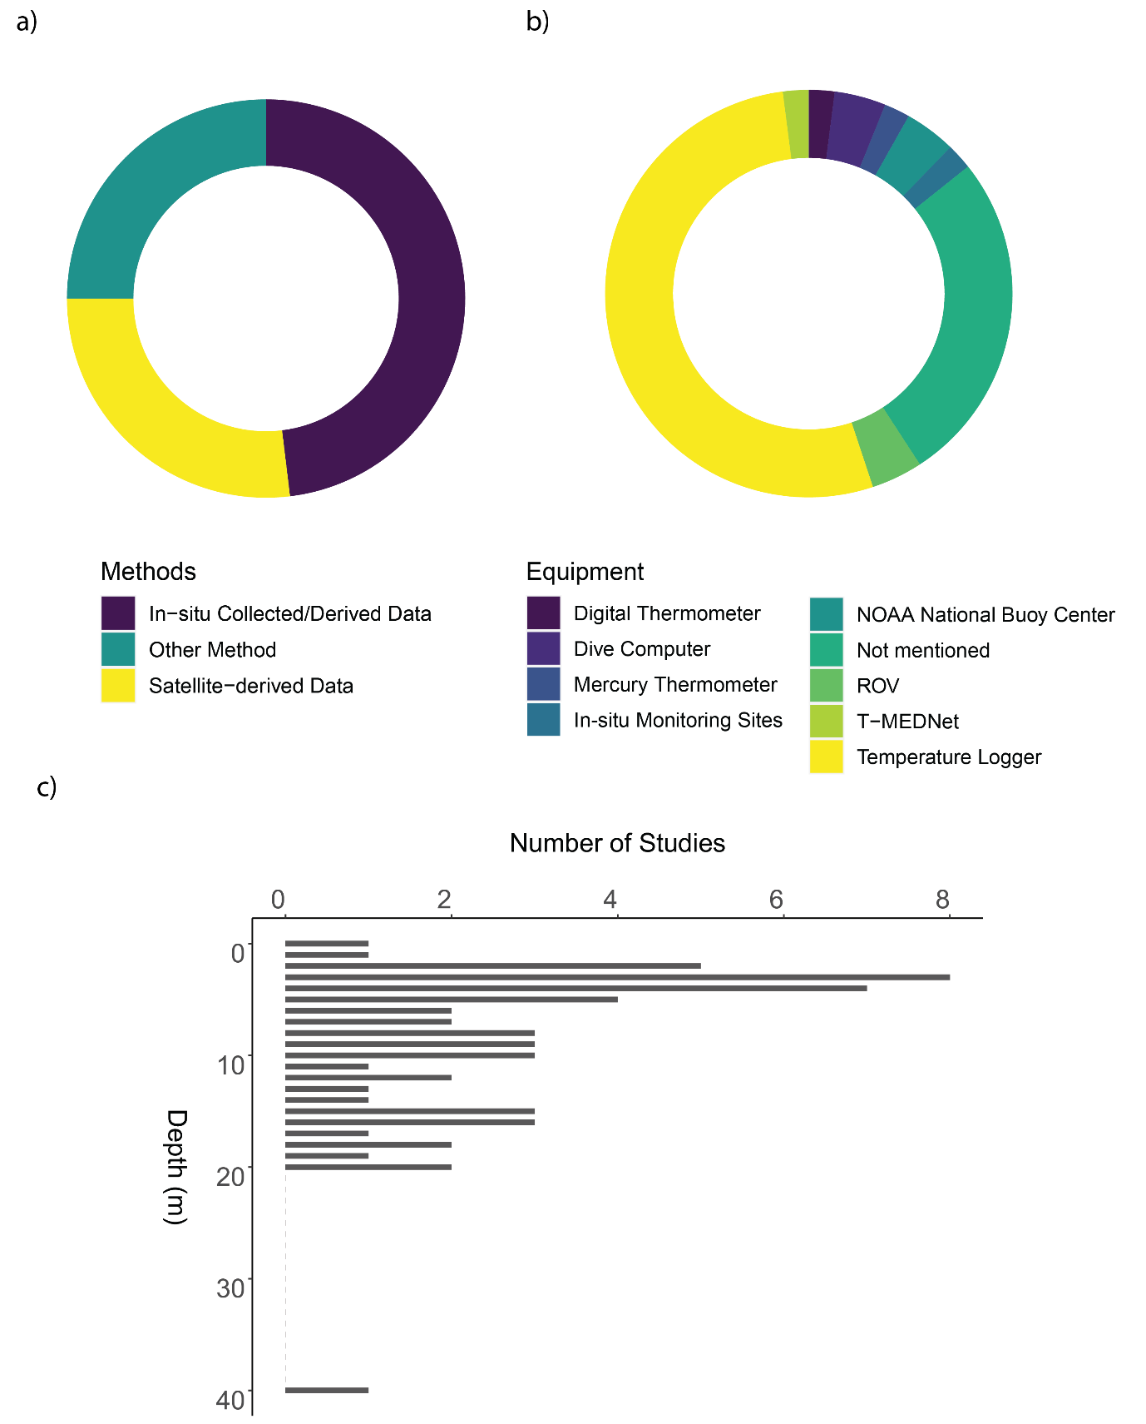

Figure 9 a) Proportion of methods of temperature recording used across the literature included in this study, created using R package ggplot2. b) Donut chart showing the proportion of equipment used for studies that recorded temperature in-situ, created using R package ggplot2. c) The depth of temperature data collection, created using R package ggplot2.